US Grade 7 – Pre-test
15 Questions | 60 minutes | Calculator allowed
1. Which expression has the greatest value when $y=50$?
- $y-10$
- $10-y$
- $y-(-10)$
- $-10-y$

2. $\frac{3}{4}$ of a serving has $\frac{1}{3}$ of a cup of fruit. How many cups of fruit are in 1 serving?
- $2\frac{1}{4}$
- $1\frac{1}{12}$
- $\frac{7}{12}$
- $\frac{4}{9}$

3. A bag contains red marbles, blue marbles and green marbles. The number of each of the marbles in the bag is as follows: 15 red marbles, 10 blue marbles, and 20 green marbles.
What is the probability that the marble selected is NOT green?
- $\frac{15}{45}$
- $\frac{5}{9}$
- $\frac{4}{5}$
- $\frac{4}{9}$

4. A pair of shoes that were originally $66.00 are on sale for 40% off. After the discount and the addition of a 7% sales tax. How much will you pay for the shoes? Choose the equation representing the total cost, $c$.
- $(66×0.6)×1.07=c$
- $66×0.4×0.07=c$
- $66×0.4+1.07=c$
- $66×0.6+66×0.07=c$

5. A store sells 6 pairs of socks for $15. They also sell 8 pairs of socks for $16.99. What is the difference between the unit rates?
- $0.25 per pair
- $2.12 per pair
- $0.38 per pair
- $1.99 per pair

6. Which value of $x$ makes the equation true?
$3(x-5)-6=-\frac{1}{2}(6x-18)$
- $x= -5$
- $x=4$
- $x= -4$
- $x=5$

7. A school is building a new fence around their circular compost bin, shown in the diagram below.
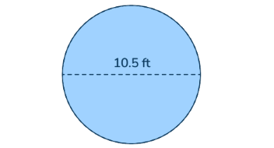
How many feet of fencing is needed to enclose the compost bin?
- 32.99 ft
- 16.485 ft
- 86.546 ft
- 65.94 ft

8. The orange triangle is a scaled version of the blue triangle. What is the missing height?
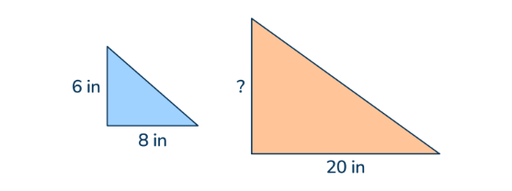
- 2.4 in
- 18 in
- 12.5 in
- 15 in

9. Which expression is equivalent to $-45x+9$?
- $-3(15x-3)$
- $9(5x+1)$
- $-9(-5x+1)$
- $3(15x-3)$

10. Bill runs $7\frac{1}{2}$ miles in $1\frac{1}{4}$ hours. What is his average speed in miles per hour?
- $7\frac{1}{10}$ mph
- 6 mph
- $7\frac{1}{5}$ mph
- $6\frac{3}{10}$ mph

11. The figure shows line YP and two angles formed by ray ED. Solve for $x.$
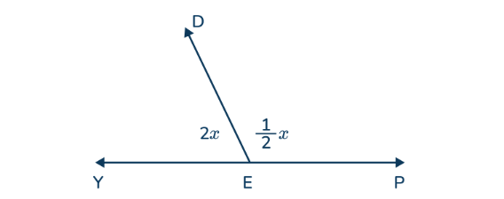
- 144
- 72
- 36
- 180

12. Erica bought two pairs of shoes for $24.99 each. She also bought a pack of socks for $8. What was the total cost, including a 7% sales tax?
- $35.30
- $53.92
- $57.98
- $62.04

13. There are three different colors of marbles in a bag. If the probability of getting blue is $\frac{1}{3}$ and the probability of getting yellow is $\frac{2}{5}$, what is the probability of getting red?
- $\frac{13}{15}$
- $\frac{11}{15}$
- $\frac{4}{15}$
- $\frac{2}{15}$

14. Marta sells bracelets for $8 each. She has already sold 5 bracelets, $b$. She wants to earn at least $90. Write an inequality to represent the situation.
- $5b+8≥90$
- $5b+8≤90$
- $8b+40≤90$
- $8b+40≥90$

15. What is the equation shown by the table?
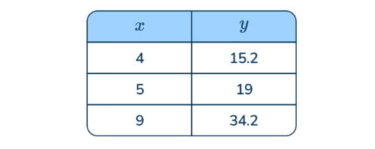
- $11.2x=y$
- $11.2+x=y$
- $3.8x=y$
- $3.8+x=y$

